Project 1 - Exploring Weather Trends

# Outline

## What is the project?

In this project I will be looking at weather trends globally and locally in my city **Perth** **Australia**, where I have been living for the past couple of decades. I am familiar with weather trends in my city and I am interested to see how it will compare with the rest of the world.

## How will I accomplish this?

To compare results, I firstly need two sets of data.

1. Perth yearly weather data
2. Global yearly weather data

I firstly need to communicate with the database (which Udacity has provided) to get these sets of data, in which case I will use a couple of SQL commands to achieve this.

SQL used to for Perth yearly weather data:

* SELECT * FROM city_data where city = 'Perth'

SQL used for global yearly weather data:

* SELECT * FROM global_data

Using the Download CSV button provided, I can download each of these sets of data onto my local computer. From here I created a new Google Sheets, and used the **import csv** feature to get both into the same sheet but in two different tabs.

From here I created two line-charts for each sheet:

1. **Average yearly** temperature data
2. **10 Year moving average** temperature data

These two charts allow me to grasp a full understanding of not only the constant ups and downs throughout the years, but more importantly, to view the overall trends of the temperature using a 10 years moving average.

Below are a few settings that I set to achieve the best visual experience for these charts:

* Set **x-axis** to years
* Set **y-axis** to temperature
* Set a minimum and maximum temperature to exclude unused temperature data and create a better viewing experience of the chart.
* Plotted null values by using the checkbox which is provided by Google Sheets.
* Started both local and global charts at the same year of 1852.
* Resized them appropriately.

I have started both sets of data at the year 1852 because that is the first year data that I have access to for **Perth Australia** and it does not make sense to compare results on previous years. This way both data are of the same timeline and hence I can proceed to compare them appropriately.

# Line charts

## Perth line charts

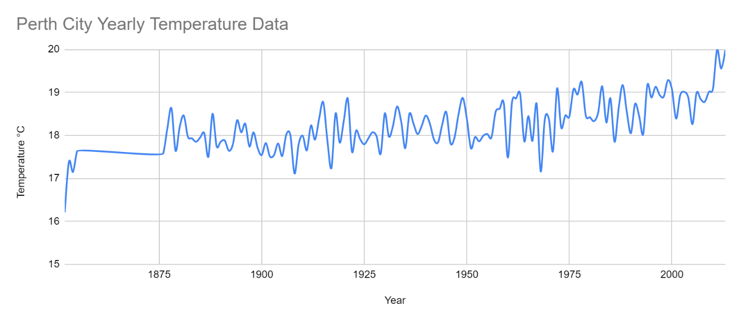

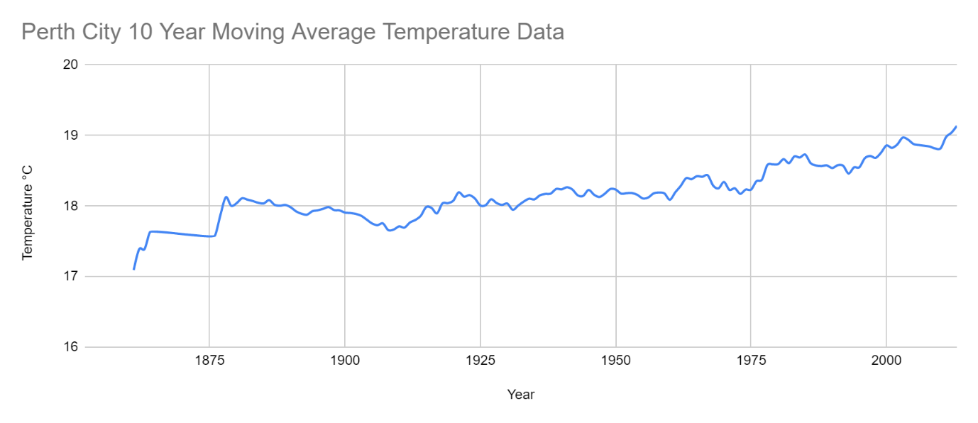

## Global line charts

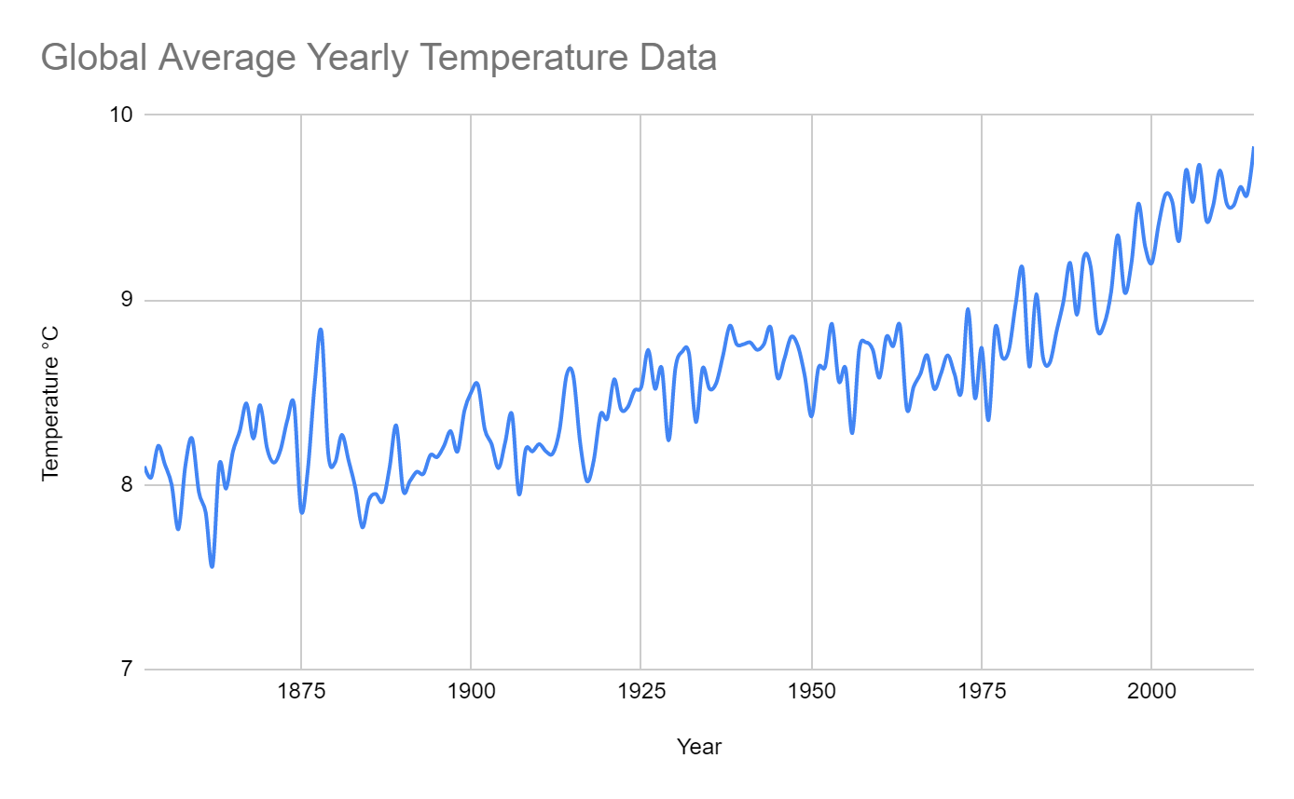

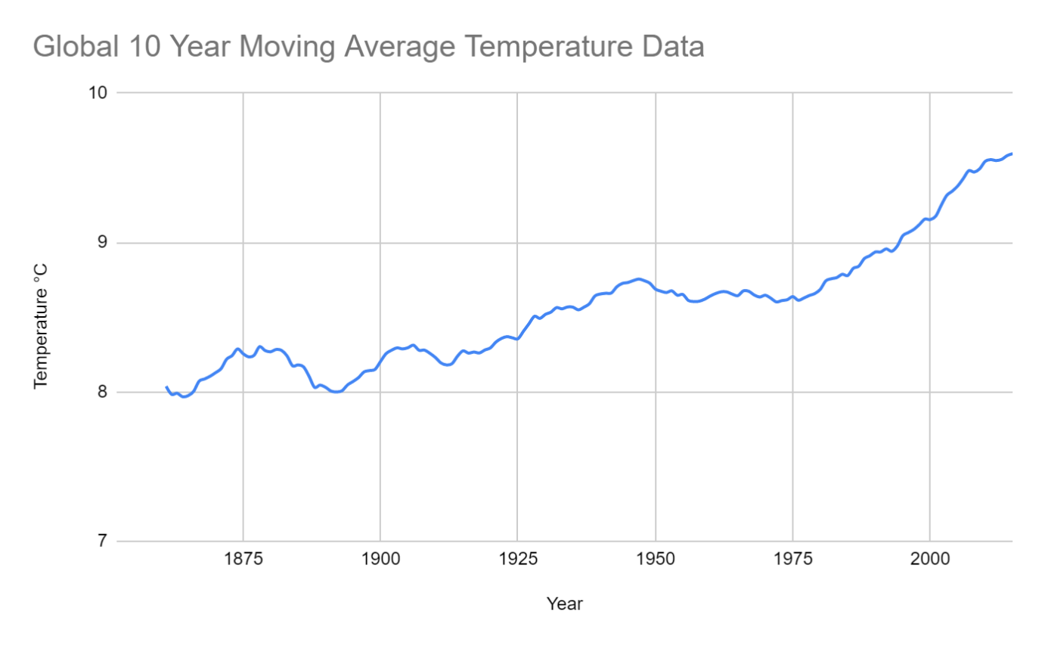

# Observations

## Differences between local and global trends?

Trends from both local and global moving average charts are showing us that both are growing. We can see similarities straight away from 1925 as both Perth temperatures and global temperatures begin to take a big leap increasing by 1°C on average, which is a big jump in the grand scheme of things, it is an indication that global warming is taking place.

Perth is growing more steadily in general and looks almost stagnate from 1875 to 1950, then it starts to pick up again. Where as globally, it is easy to see that in general it’s a upward growth since the beginning, and specially since 1925.

## How does Perth temperature compare to global temperatures over time?

**Perth Australia** is a hot tropical city in comparison to the global weathers and we can see this reflected in the charts.

Throughout the years, Perth has been averaging temperatures between 17°C and 20°C.

In the same timeframe, global temperatures have been averaging between 8°C to 10°C.

This is because when we take all countries into account for the global data, we are including locations which are freezing even below zero, such as Russia. This will bring down the average quite dramatically.

## How have Perth temperatures changed in comparison to global data?

By observing the 10-year moving average temperature data charts, we can see that in both cases locally and globally, that the temperatures are rising over the years. This is the effect of global warming.

Both local and global temperatures have fluctuated within a 2°C margin, however it is interesting to notice that this rise in temperature locally, due to global warming, has had a more gradual growth, in comparison to global temperatures which seem to be rapidly increasing.

## Have the trends been consistent over the past few hundred years?

Yes, definitely in the past few hundred years, we can see from the charts that there has been a consistent growth in temperature all around the world, including **Perth Australia.**

I have noticed that between 1875 and 1925, it has been quite a steady trend both locally and globally. Though we are experiencing an overall rise in temperature through the century, it seems there has been a pause in this increase for 50 years. After this period, the temperatures started picking up again and I believe at this stage, global warming started to take effect more rapidly.